Dishwasher System Analysis

Use Case Diagram – Dishwasher

Diagram 1: Use Case Diagram

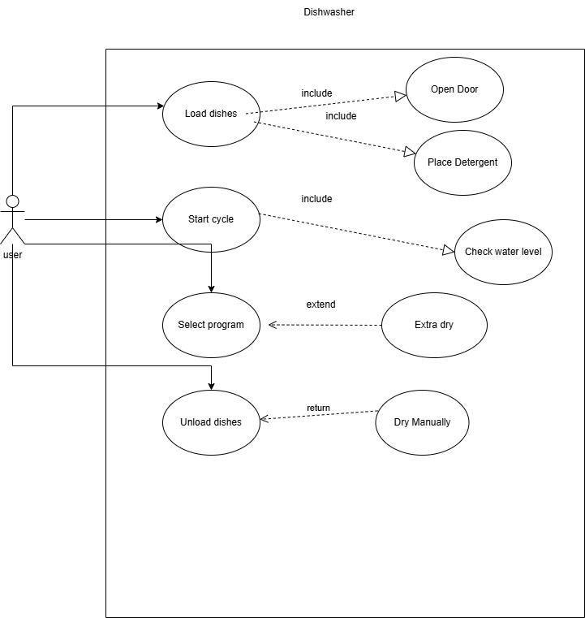
The use case diagram models the interaction between the User and the Dishwasher system, focusing on the main scenarios involved in operating a dishwasher. It shows external behavior from the user's perspective.
Actors:
- User: Operates the dishwasher—loads dishes, selects programs, starts or pauses cycles, monitors progress, and unloads dishes.
- System: Includes any required external services (water, power, maintenance).
Use Cases:
- Load Dishes: User puts dirty dishes in the machine.
- Add Detergent: User adds detergent before starting the wash.
- Select Program: User selects wash cycle (Normal, Eco, Intensive, etc.).
- Start/Pause Cycle: User starts or pauses the operation.
- Monitor Progress: User can see the current state of the cycle.
- Receive Alerts: System notifies user about errors or states (e.g., water supply low).
- Unload Dishes: User removes clean dishes at the end.

Block Definition Diagram (BDD) – Top Level

Diagram 2: BDD – Dishwasher Structure

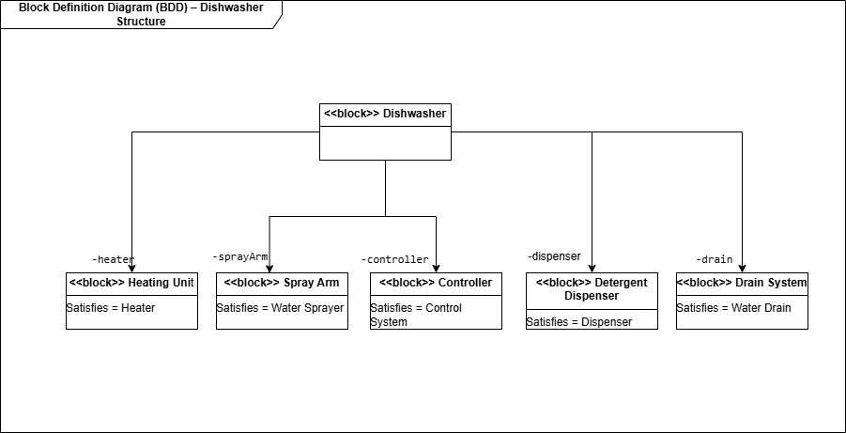
The Block Definition Diagram (BDD) shows the structural decomposition of the dishwasher system, with the main blocks and their roles.
Main Block:
- Dishwasher: Top-level system.
Sub-Blocks:
- Heating Unit: Heats the water.
- Spray Arm: Distributes water inside.
- Controller: Manages cycles and operations.
- Detergent Dispenser: Dispenses cleaning agent.
- Drain System: Removes waste water.

Activity Diagram – Black Box Scenario

Diagram 3: Activity Diagram – Black Box
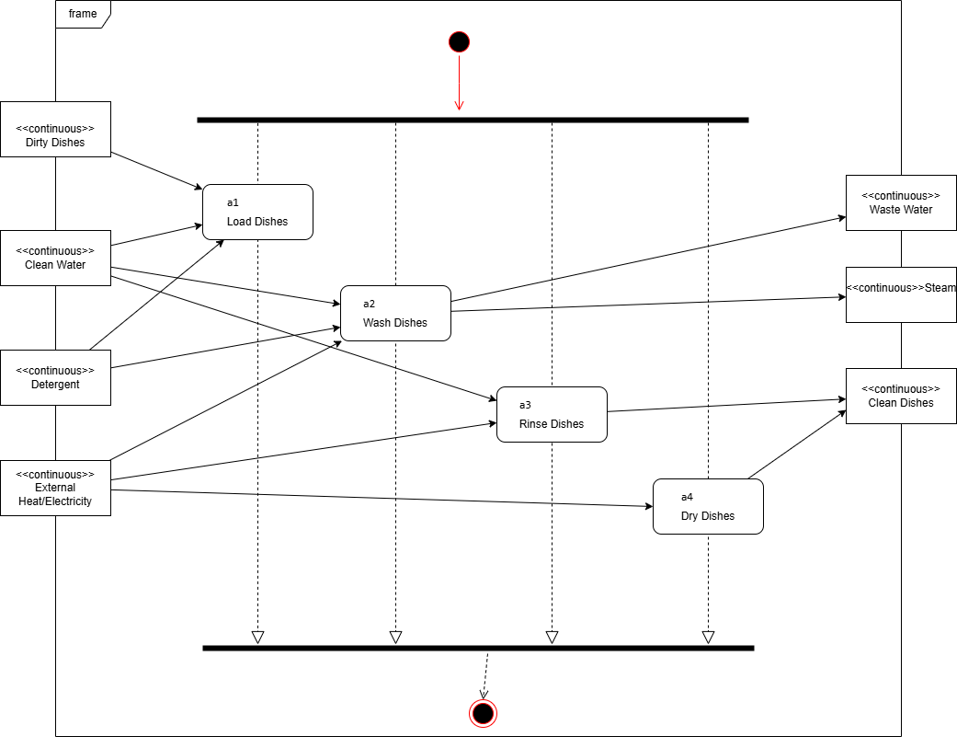
Shows the dishwasher’s operational flow from start to finish as a “black box”.
Inputs:
- Dirty Dishes
- Water
- Detergent
- Electrical Power
Flow:
1. Load Dishes: Place dirty dishes in the washer.
2. Add Detergent: Add detergent.
3. Wash Dishes: Clean with water and detergent. Output: Waste Water
4. Dry Dishes: Uses power to dry. Output: Steam
5. End Cycle. Output: Clean Dishes

4. Block Definition Diagram – Input/Output Definitions
Shows how the dishwasher is structurally decomposed into subsystems and their relationships, focusing on key interfaces and flows.
Diagram 4: BDD – Input/Output
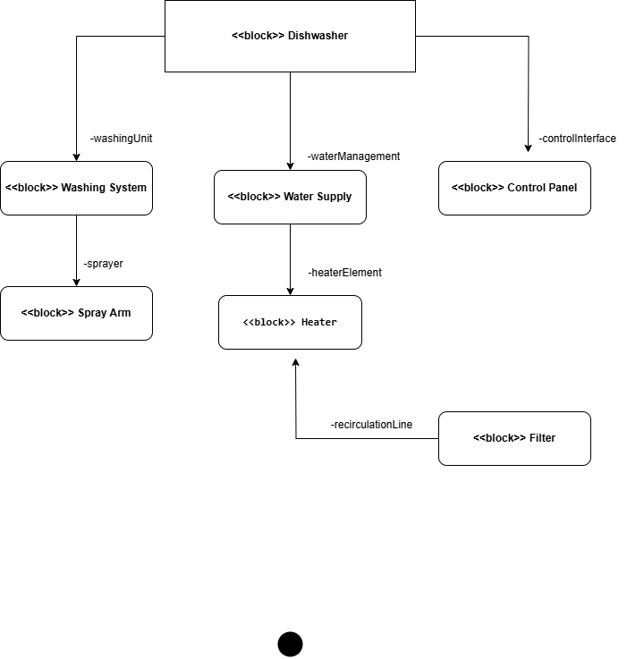

5. Block Definition Diagram – Dishwasher Hierarchy
Shows the main system and subsystems, highlighting the architectural hierarchy.
- Dishwasher
- Control Panel
- Washing System (with Spray Arm, Filter)
- Water Supply
- Heater
Diagram 5: Dishwasher Hierarchy
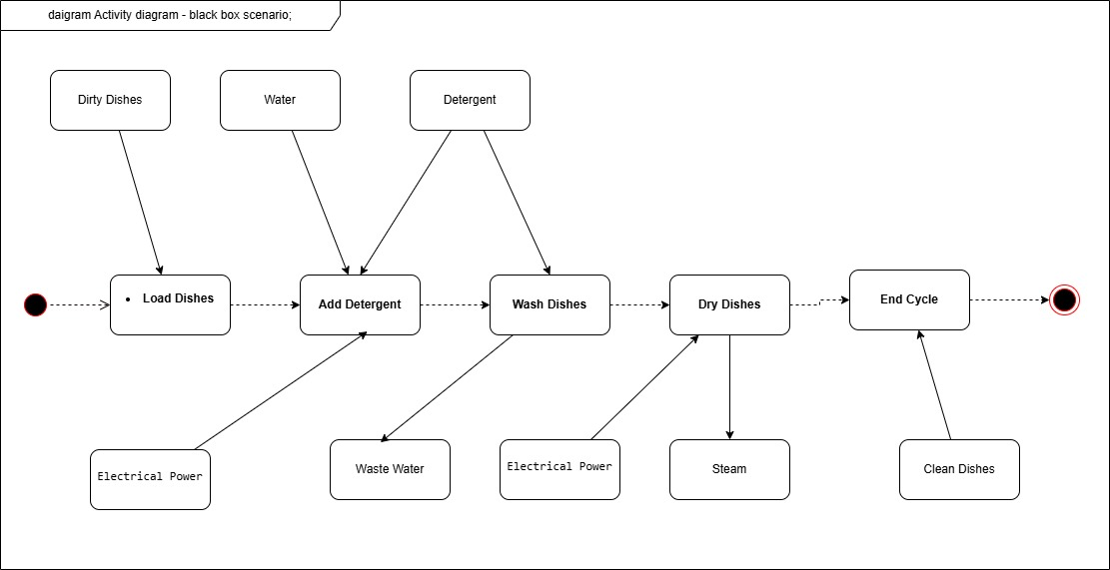

6. Activity Diagram – White Box Scenario
Shows the internal operational workflow in sequence:
1. Load Dishes
2. Add Detergent
3. Wash Dishes
4. Drain Water
5. Dry Dishes
Diagram 6: Activity Diagram – White Box
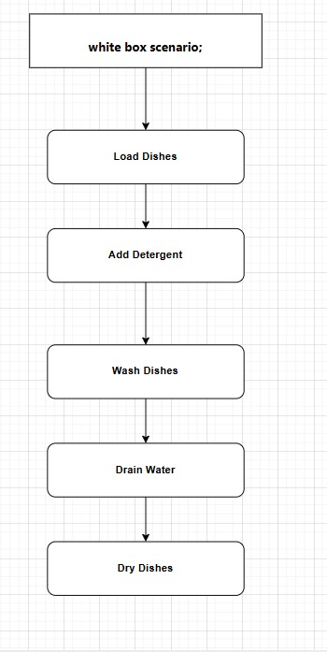

7. State Machine Diagram – Dishwasher States
Illustrates the main operational states and transitions:
Idle → Filling Water → Washing → Rinsing → Drying → Idle
Diagram 7: State Machine Diagram
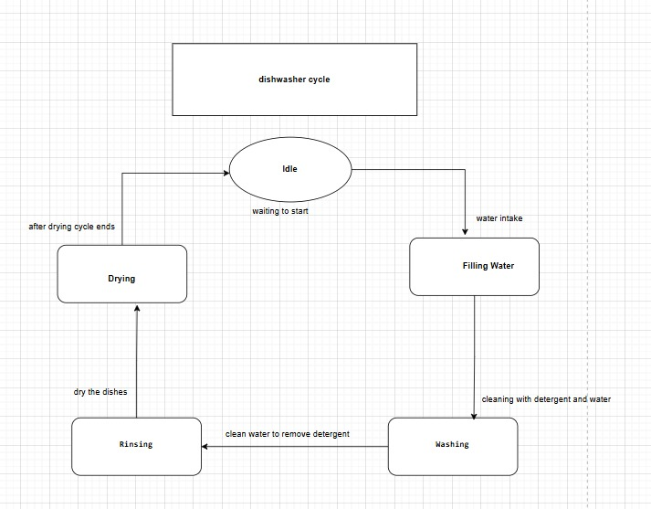

8. Sequence Diagram – Interactions Between Dishwasher Parts
Shows the time-based sequence of actions between components:
- Dishwasher
- Washing System
- Detergent Dispenser
- Control Panel
Diagram 8: Sequence Diagram
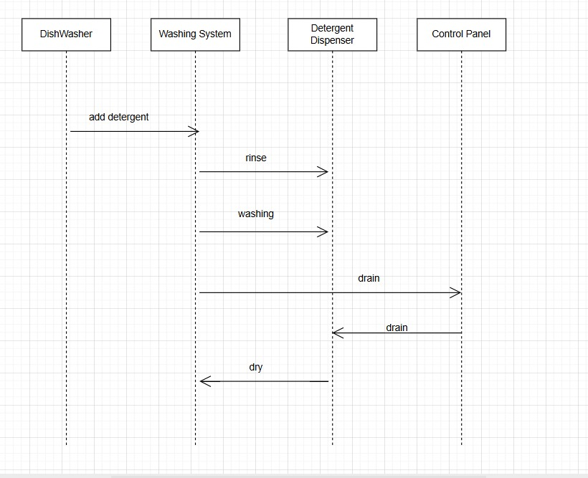

Explanations of Diagrams
Block Definition Diagram (BDD):
Shows main system structure, blocks, and responsibilities. Helps understand which part does what.
Activity Diagrams:
- Black Box: Focus on input/output and overall process.
- White Box: Step-by-step flow inside the system.
State Machine Diagram:
Displays main states and how dishwasher progresses through its operation.
Sequence Diagram:
Demonstrates interaction and message flow between components in real time.

